Cancelling a FS block/slides (once slide stickers are printed)
*Must be performed by someone with access. If none are available leave a note to be fixed next working day (if weekend/after hours) or email IT.
Select Accession Entry/Edit
Select Histology Tab
Select Stain/Process detail
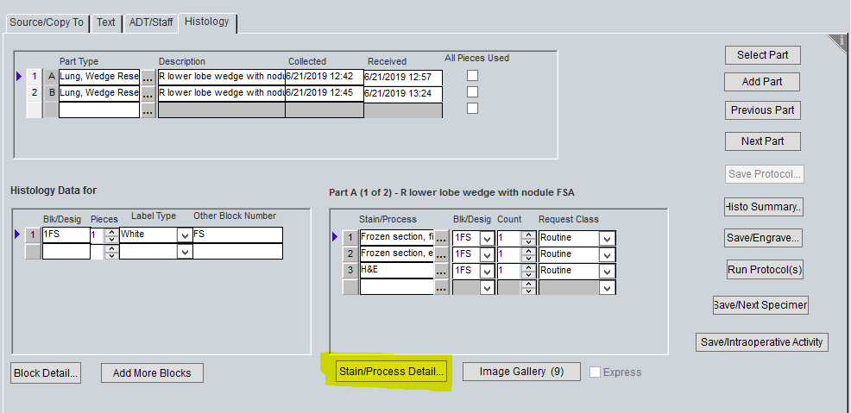
Change “delivered” status on FS slides to “cancelled” and click “OK”
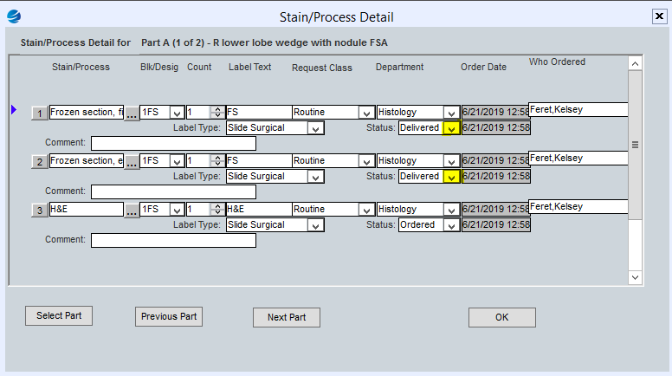
Make sure blue arrow is highlighting FS block you want to cancel in lower left field
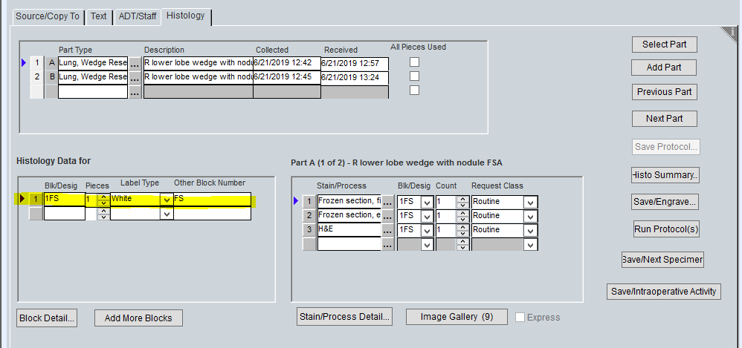
Either right click and select “delete” or press CTRL + D, click “save” and return to Source/Copy To and can load a different protocol and print cassettes.
*Don’t forget to access the “Save/Intraoperative Activity” and delete the info for the frozen that didn’t happen, BUT leave there if changed to intra-op exam.
To delete, select the ordered date for the part and right click and select “delete” or press CTRL + D

